Criterion E: Product development

# Complex techniques used to address the client’s requirements:

1. Use of CSS to maintain consistency (theme) in all web pages
2. Manipulation of graphics
3. Creation of a new logo
4. Favicon for the website’s tab
5. Embedding a video
6. Embedding Google maps
7. Connecting Google forms to customized form
8. The landing page consisting of the logo, a caption and a progress bar
9. Dropdowns and menu hover effects
10. Album slider with overlay text on hover
11. Ribbon title holder animation

# Only the highlighted complex techniques in the list are explained because of limited word count.

# **Organisation of the webpage (Document object model)**

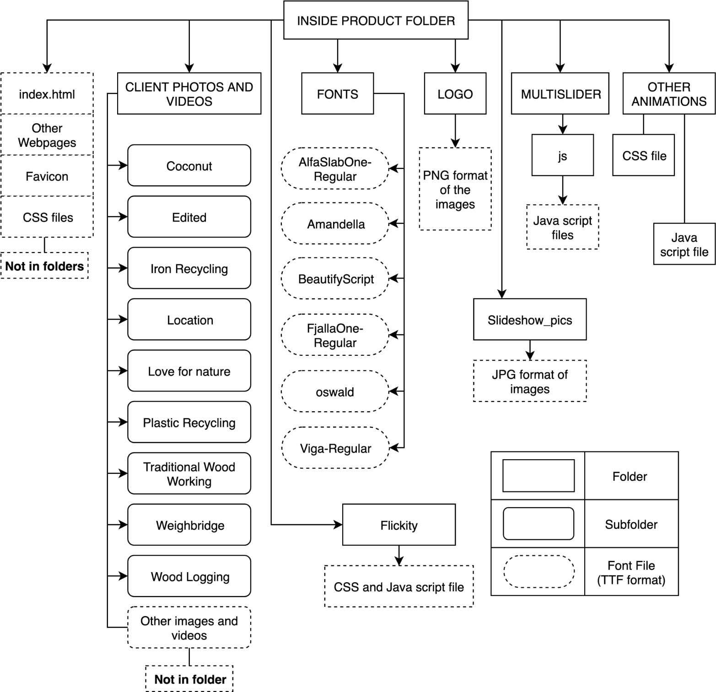This indicates how the website is structured in the product file:

Jpg and Png format images

The content had been placed in specific folders with appropriate names. For example, the images of the client’s businesses were placed in a folder. These images were further categorized into subfolders for easy access during replacements or when new photos have to be added.

The web pages and the main CSS files required for the website were not placed in folders so that they can be accessed readily for future developments of the website. Few CSS files like the CSS for animations, transitions and menu hover effects were placed in folders since they were not to be changed much.

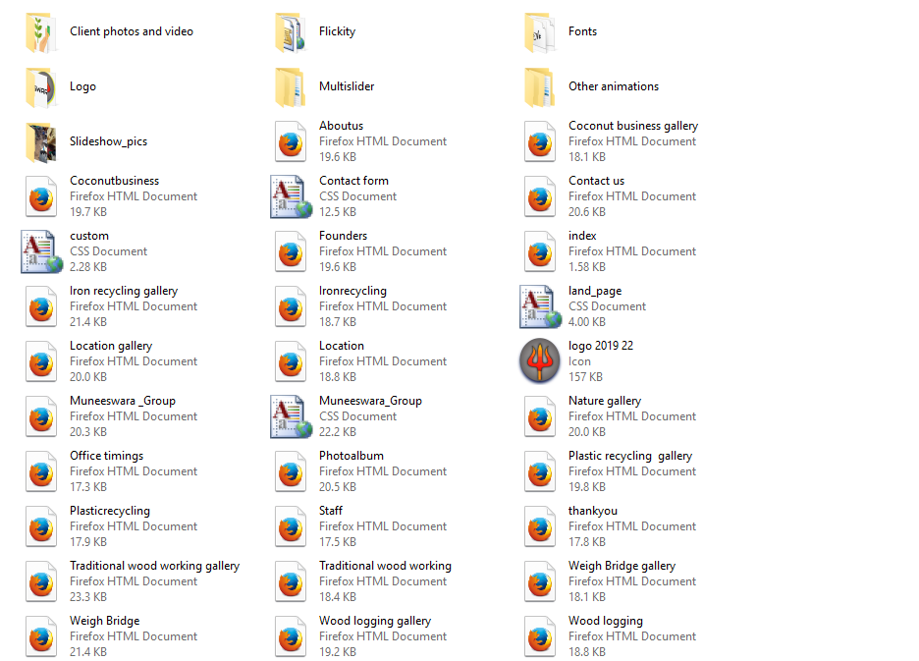

# **The structure and organisation of the web pages**

**Technique: Logo**

An online software called **sketch.io (**[**https://sketch.io/**](https://sketch.io/)**)** and **you i draw (**[**https://site.youidraw.com**](https://site.youidraw.com)**) (logo maker)** was used collectively for the creation of the logo. The client had told me beforehand itself, that the logo must have a trishula (a trident).

Original

Duplicate was flipped

The above was done so that the trident is symmetrical and straight . Both images were then lined up and grouped together to get a full trident. 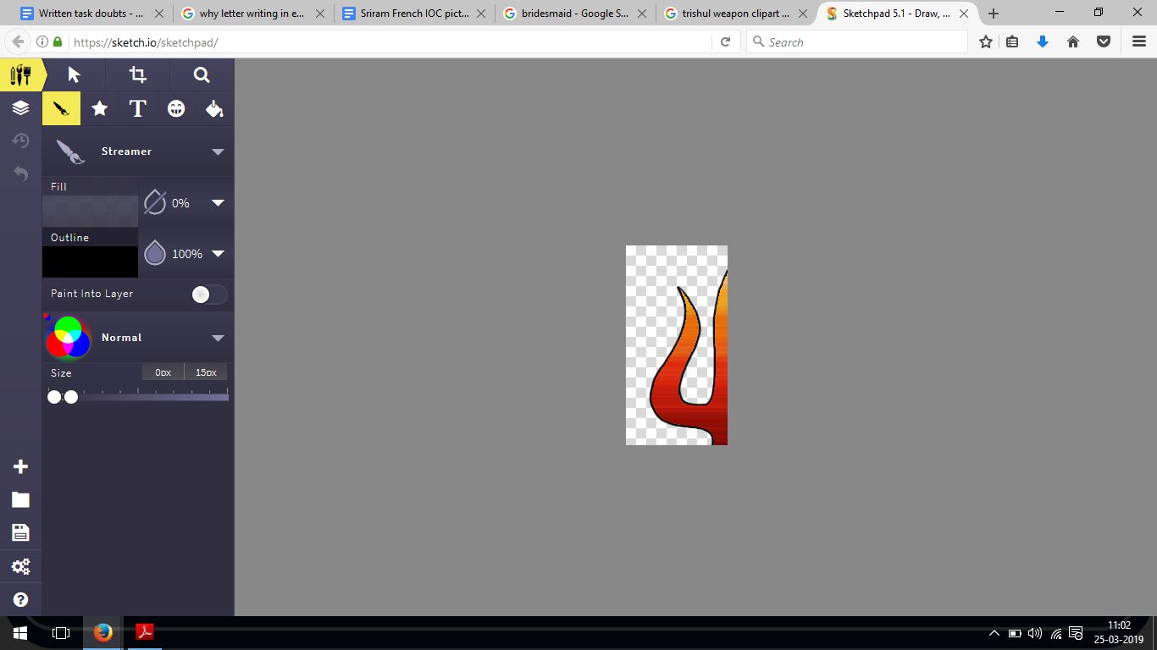The bottom part (handle of the trident) was then drawn to complete the illustration.

Colour corrections where done for making the trident slightly brighter and redder.



Before colour correction

After colour correction

A sample text of “Muneeswara” was kept under the logo instead of the full name (Muneeswarar group), to make it easier during the designing process of the logo.

The two designs below gave a basic idea of the logo’s appearance.

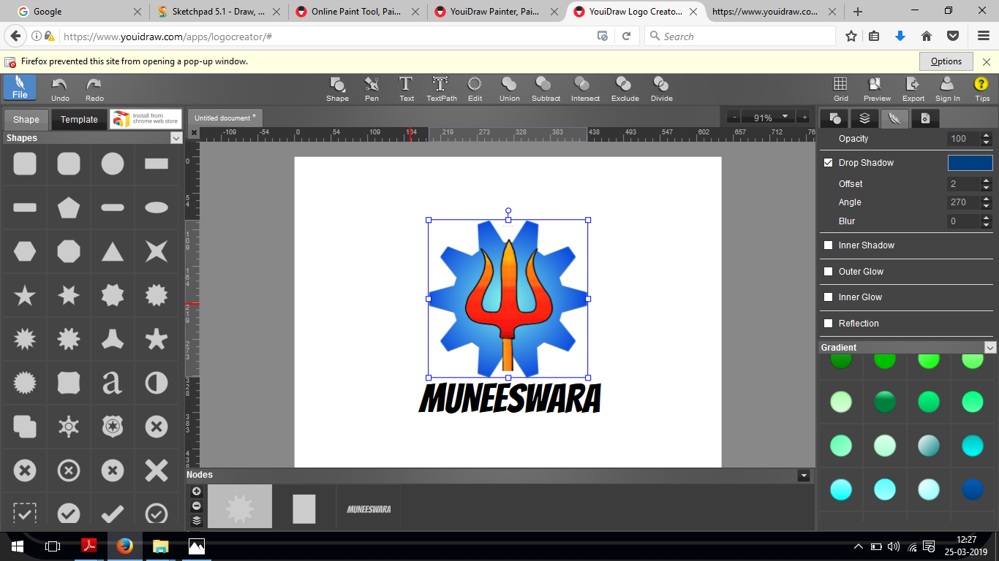

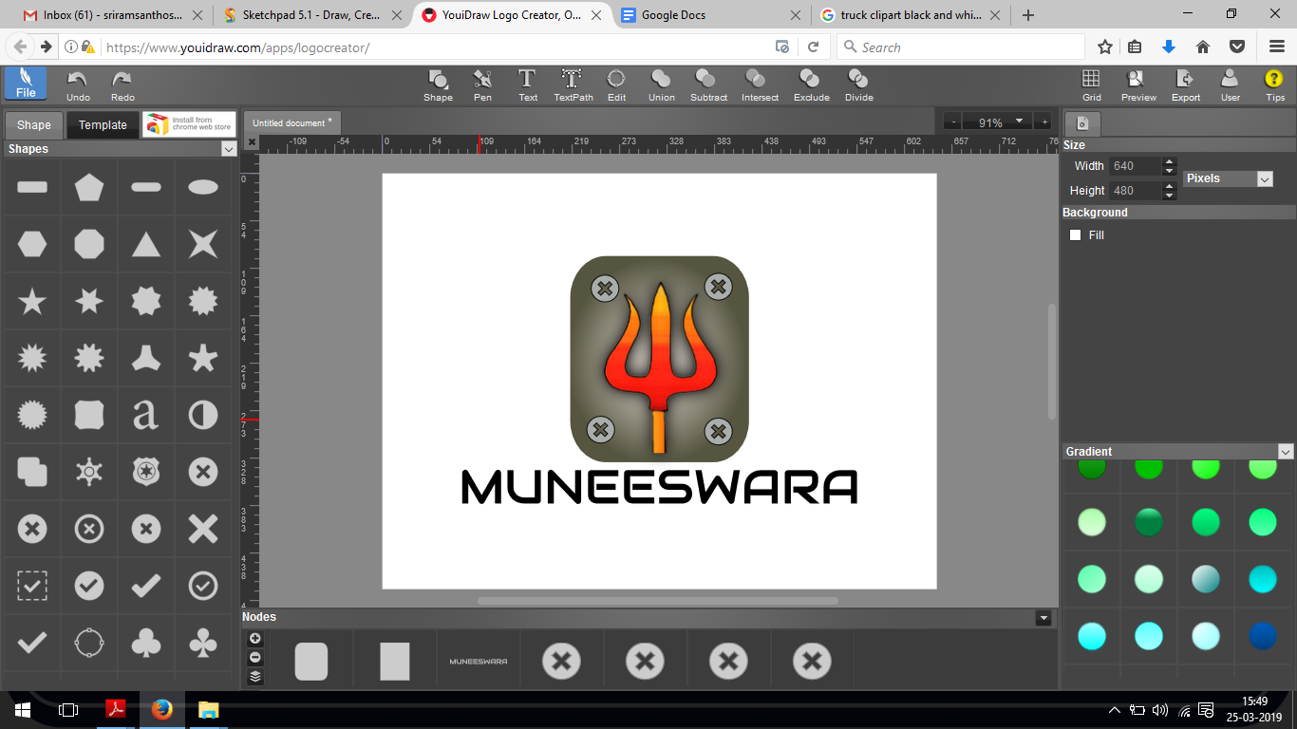

The above two designs lead me to three different designs.



3

2

1



The text on the bottom which says “Muneeswarar group” was written in the font style “Audiowide”. The client was satisfied with logo number-1 (an oval).

The final logo which was proposed:-



**Technique: Manipulation of images**

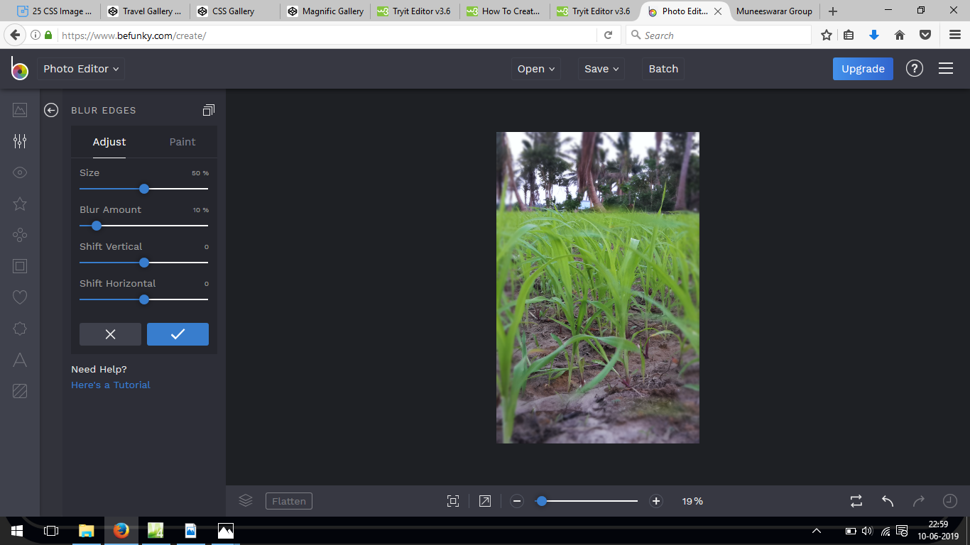Most images used were colour and temperature corrected slightly to make them more appealing and bright in the web pages. A slight blur was also given to few of the images to make them look nicer. An online software called **be funky** was used for doing these manipulations. The images in gallery have not been manipulated to sustain their natural look.

Examples of manipulated images:-

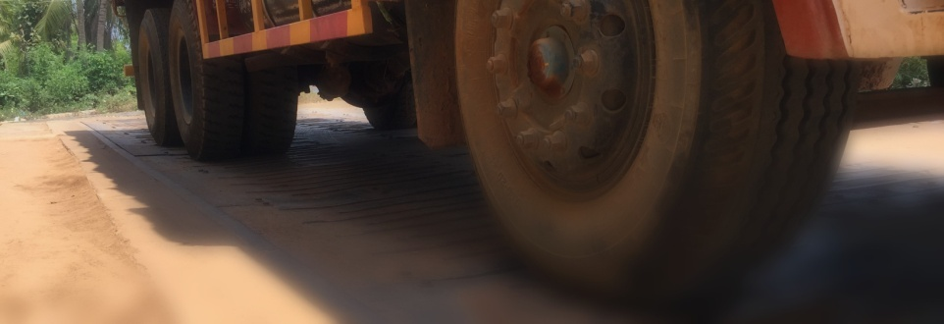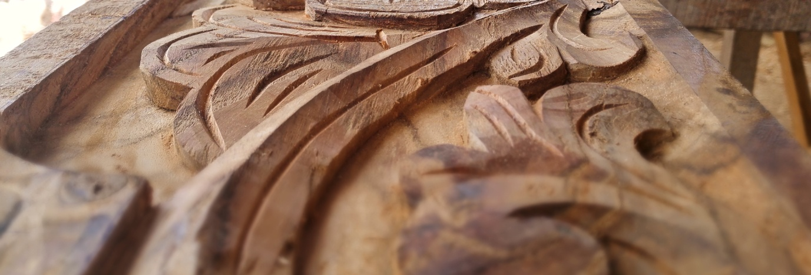



A sample image before and after editing:



**BEFORE**



**AFTER**

**Technique: Favicon**

The favicon is the small icon denoting the company’s logo and it appears on the tab of a web browser. The logo was cropped to only have the illustration and was converted from .png format to .ico format using an online converter (<https://icoconvert.com/>). The following code used to put the favicon on the browser’s tab:-

|  |  |
| --- | --- |
| **Statement** | **Meaning** |
| rel="shortcut icon" | The attribute imports an icon into the webpage. It is also used only when the href attribute is there. |
| href="logo 2019 22.ico" | The attribute specifies the browser on the location of the icon. In the code above, the location is along with all the web pages. |
| type="image/x-icon" | The attribute specifies the Internet media type of the linked icon. It will allow only the .ico format images to work as favicons. |

Result:

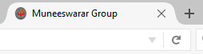

Website title

Favicon

Browser tab

**Technique: Embedding video**

**Movie maker** was used to club all the shots taken and audio together. Subtitles were then added describing the process undergoing in the video. The video was embedded in the website by the following html code.

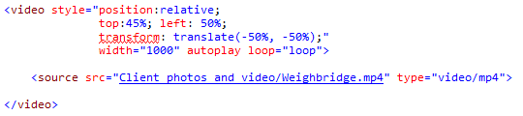

The <video> tag embeds the video in the web page. The <source> element within the <video> tag specifies the location of the video.

The style attribute describes the position of the video in the webpage and, also describes on whether the video auto play’s and loop’s again after the video finishes.

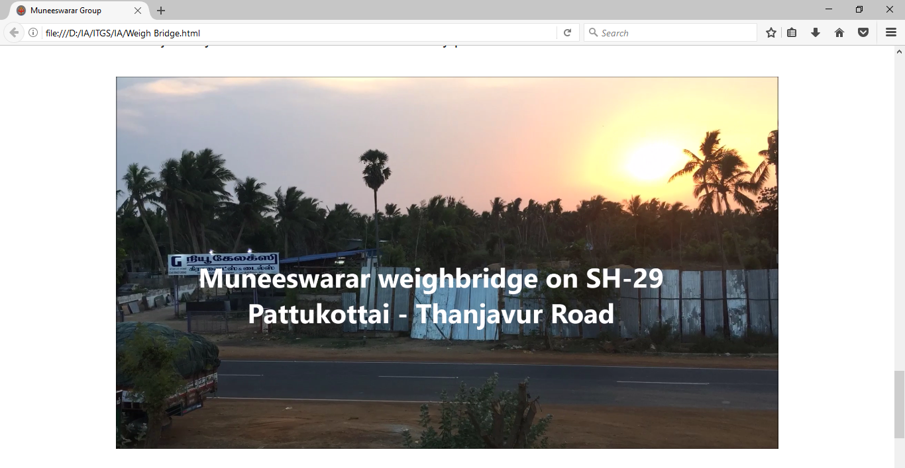

**Technique: Embedding a Google map**

A location was created for the company in Google maps using **Google My Business** since the client did not have one.



After the location got added on Google maps, the embedding code for the map was copied into the website.

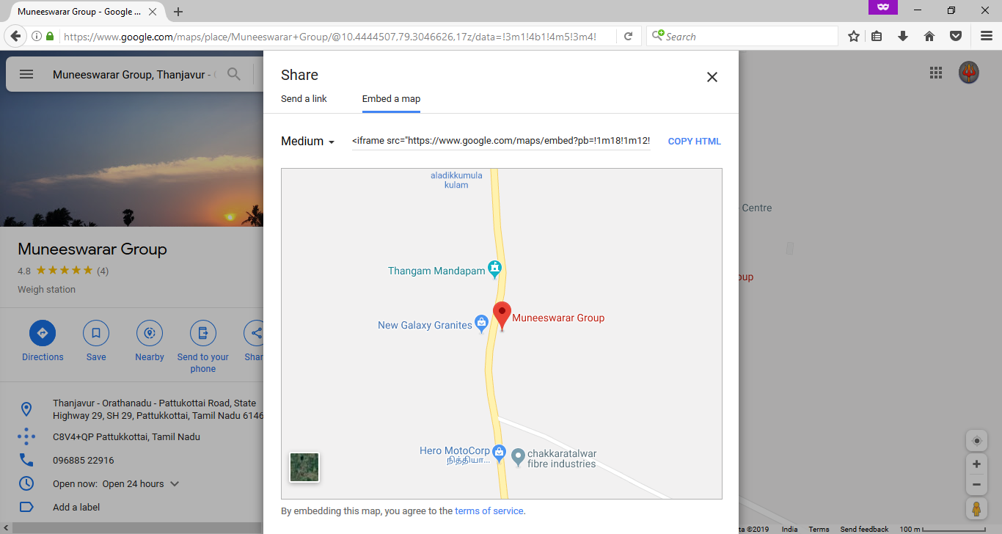

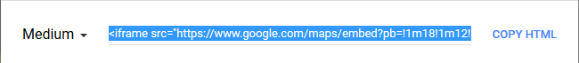

The html code for embedding the map.

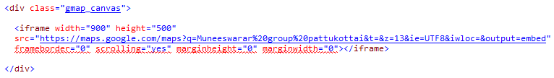

The following CSS code was used for creating a shadow around the map:-

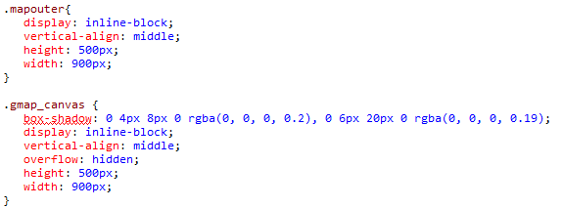

Shadow around the map’s container

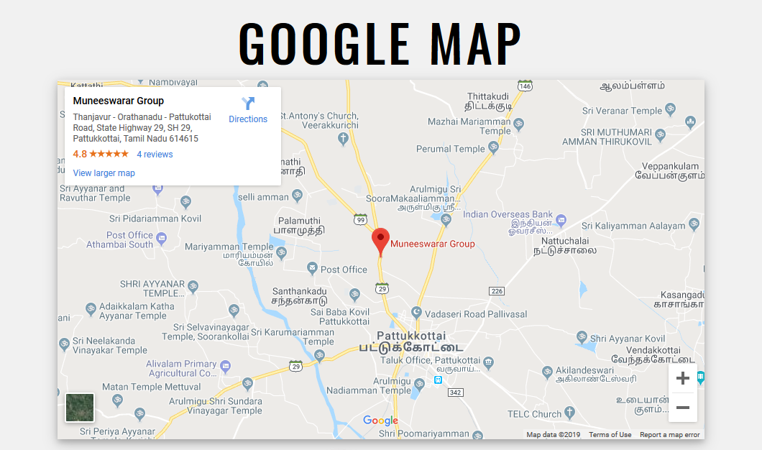Results:

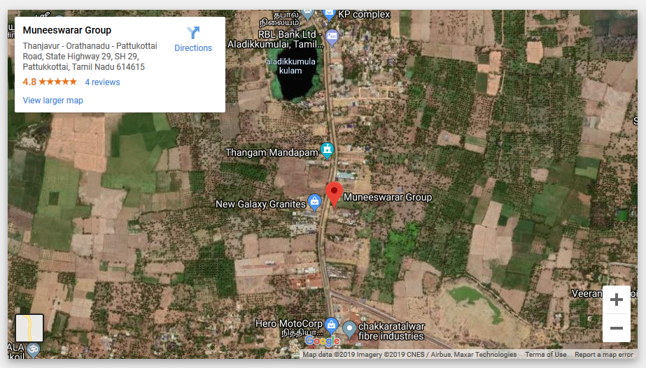

**Technique: Connecting Google forms to customized form**

The following websites were used:-

1. "How To Style Google Forms - Morning Studio". *Morning Studio*, https://morningstudio.com.au/blog/2013/06/how-to-style-google-forms/. Accessed 23 Jan 2019.
2. Visor, Bob. "Google Forms Is Brilliant!". *Medium*, 2018, https://medium.com/@weldebob/google-forms-is-brilliant-7b04765f1b8c.
3. "Customize A Google Form For Your Website". *Codepen*, 2016, https://codepen.io/learningcode/post/customize-a-google-form-for-your-website.
4. "How To Add Custom Google Forms To Your Static Site - Developer Drive". *Developerdrive.Com*, https://www.developerdrive.com/add-google-forms-static-site/.

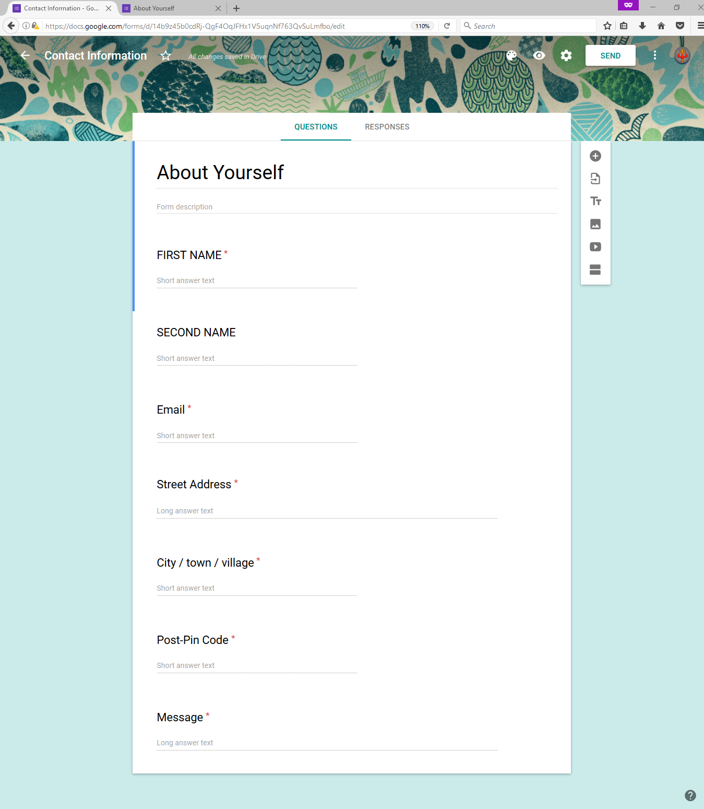A Google form with required input fields was made.

The action link for the full form was copied by using the inspect element option of the browser:-

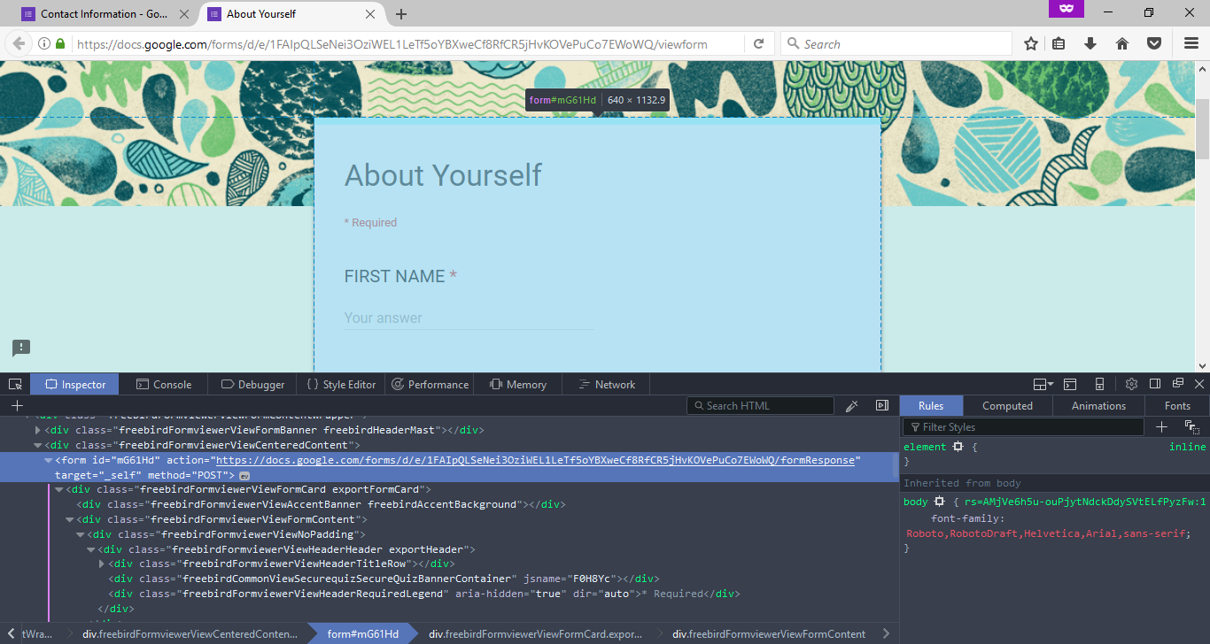

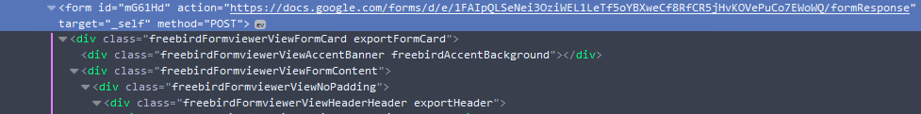

The “name” id for all the input fields were copied by using inspect element again:-

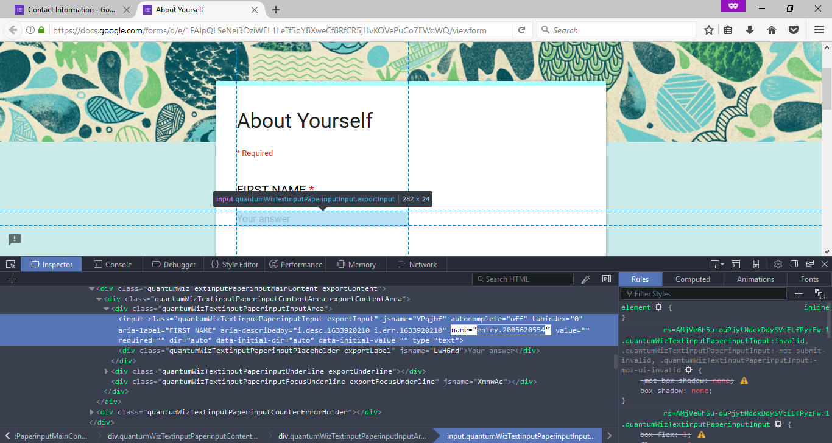



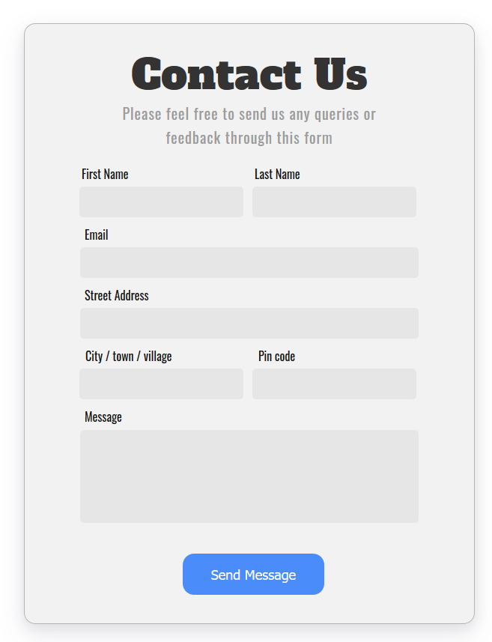Then, a custom contact form with a submit button was made for the website with the same input fields as the Google form. All the fields of both the forms are required. The **E-mail** and the **Pin code** fields have validation.

**Validation:-**

**@** and **(.) dot** are mandatory in the mail id.

**Validation:-** Only 6 digits is allowed

A thank you (response) page with a button which says **Send another message** was created.

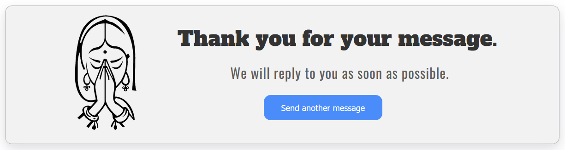

**Diagram to show relationship between the contact form, Google forms and Thank you page.**

The filled input details in the website’s contact form.

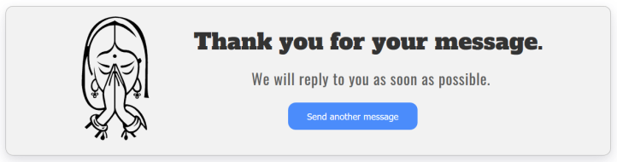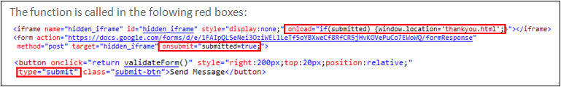

The function is

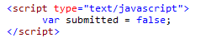

When the submit button of the form is clicked, the function is called.

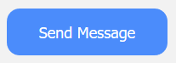

A Gmail notification is also sent by Google forms after few minutes.

**The form fields with the respective “name” id are sent to the fields Google forms**

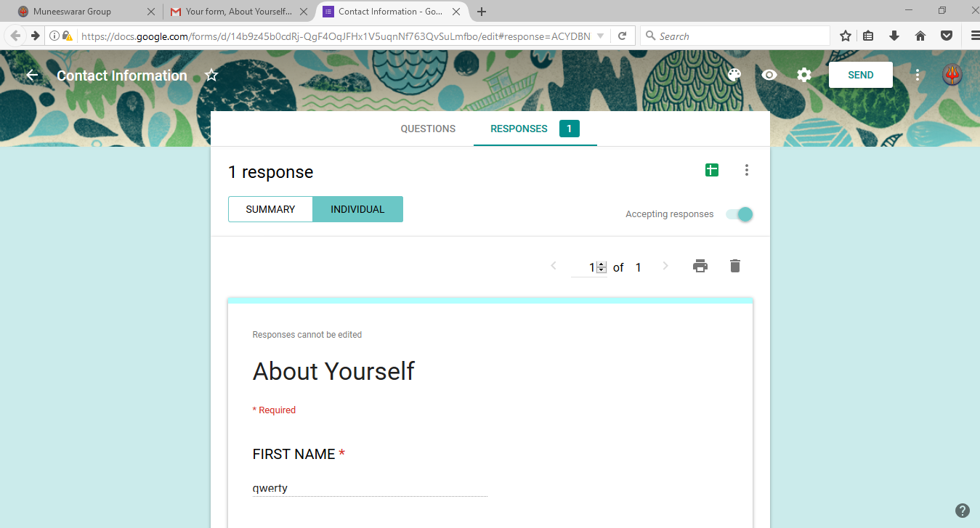

**The form fields are automatically filled in Google sheets**

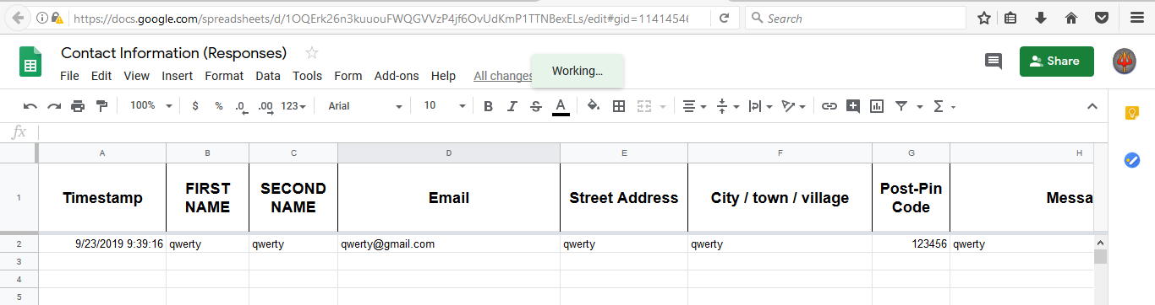

The function is called in the red boxes drawn over the code.

Use of JavaScript allows to put a custom thank page rather than the boring thank you page of Google.

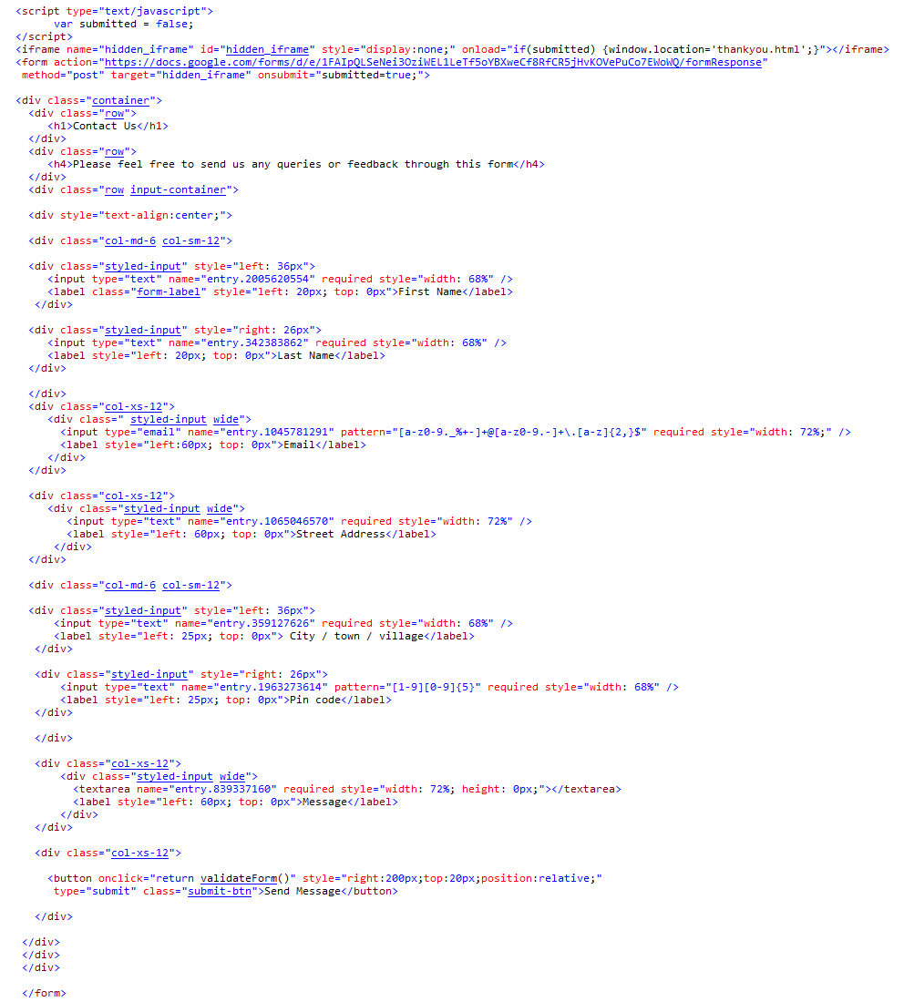The html code for the form:-

JavaScript for improving functionality of form

Pattern validation for pin code

Pattern validation for mail-id

Copied “name” id for that specific field in Google forms must be pasted here.

Copied action link

The CSS code for the form:-

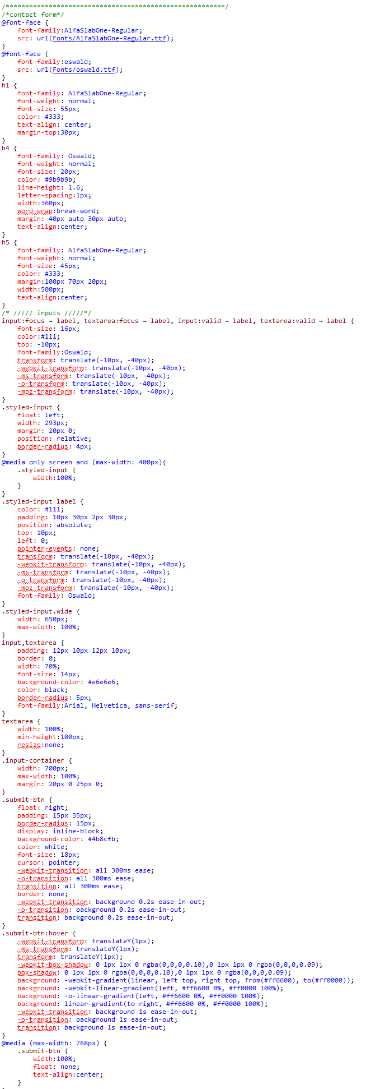

Font styling in form

Input field styling



Input field styling

Button styling

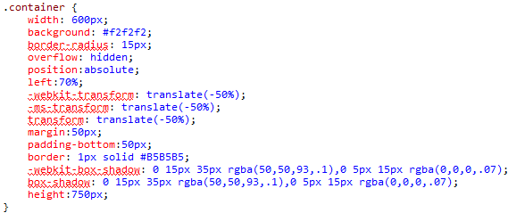

Container of form styling

The html code for the response page:-

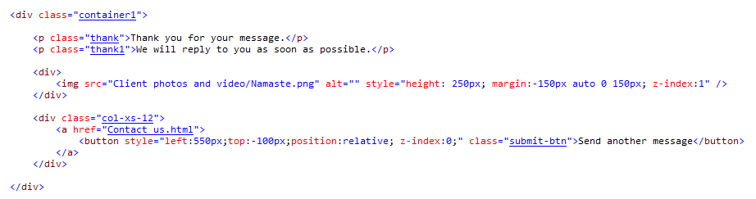

The CSS code for response page:-

The CSS code for the response page:-

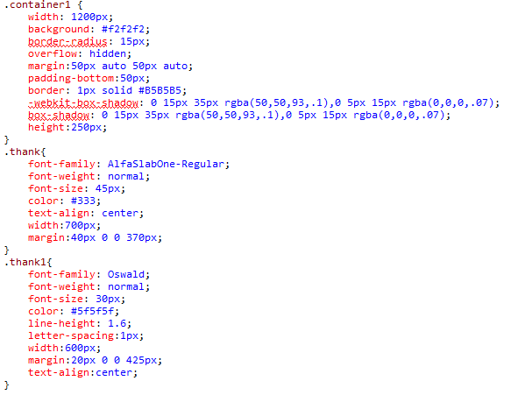

Filling the form in the website will give the client, the responses in Google forms.



Response in Google sheets:-



Google forms sends a notification to the clients mail-id also.

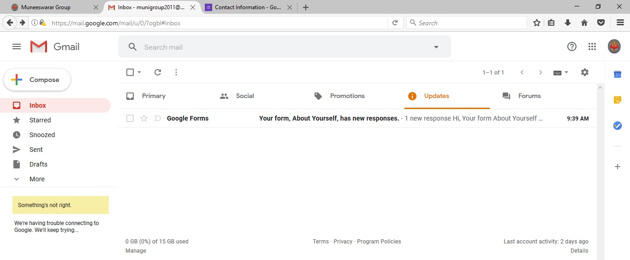

The advantage of using this method is that it can create an attractive look to the forms in the website than the standard way of embedding the code by using <iframe>. Moreover, this method is much simpler compared to the complex php coding required for making a form. The client can also have the form details organised automatically in Google sheets and Google forms.

**Technique:- The landing page consisting of the logo, a caption and a progress bar.**

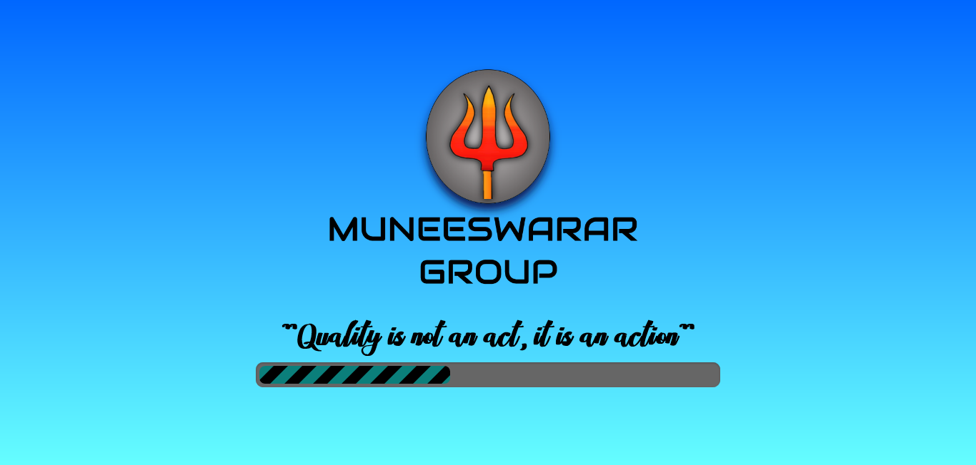The landing page with animations were done to have an attractive entry to the website.

Logo

**Gradient background**

Quote

Progress bar

The animation of the different elements was done using open source codes, **wow js** supported by **animate.css.**

* "Daneden/Animate.Css". *Github*, 2018, https://github.com/daneden/animate.css/.
* "Graingert/WOW". *Github*, 2016, https://github.com/graingert/WOW/.
* "Wow.Js — Reveal Animations When Scrolling". *Wowjs.Uk*, https://wowjs.uk/.

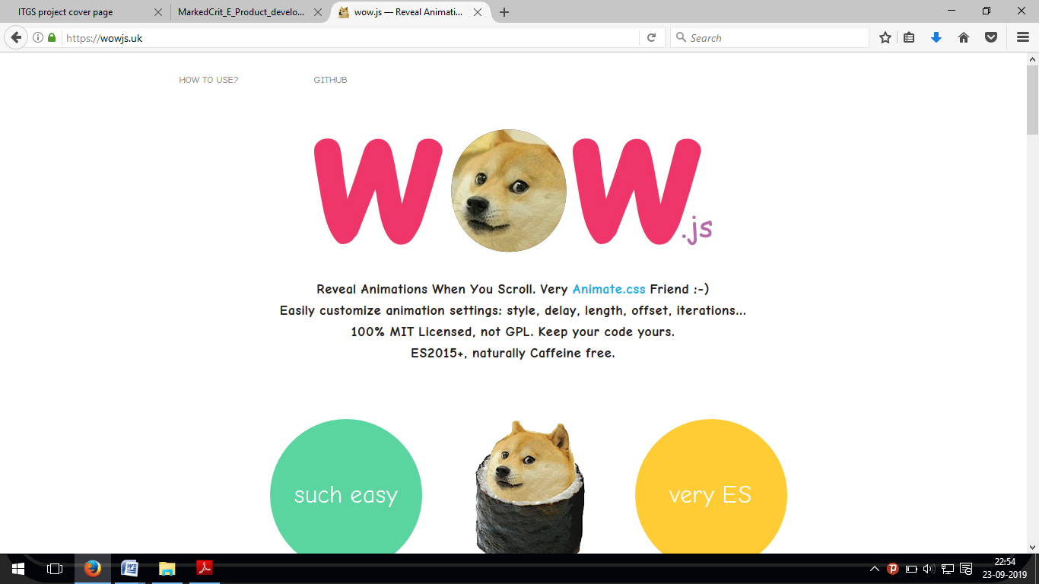

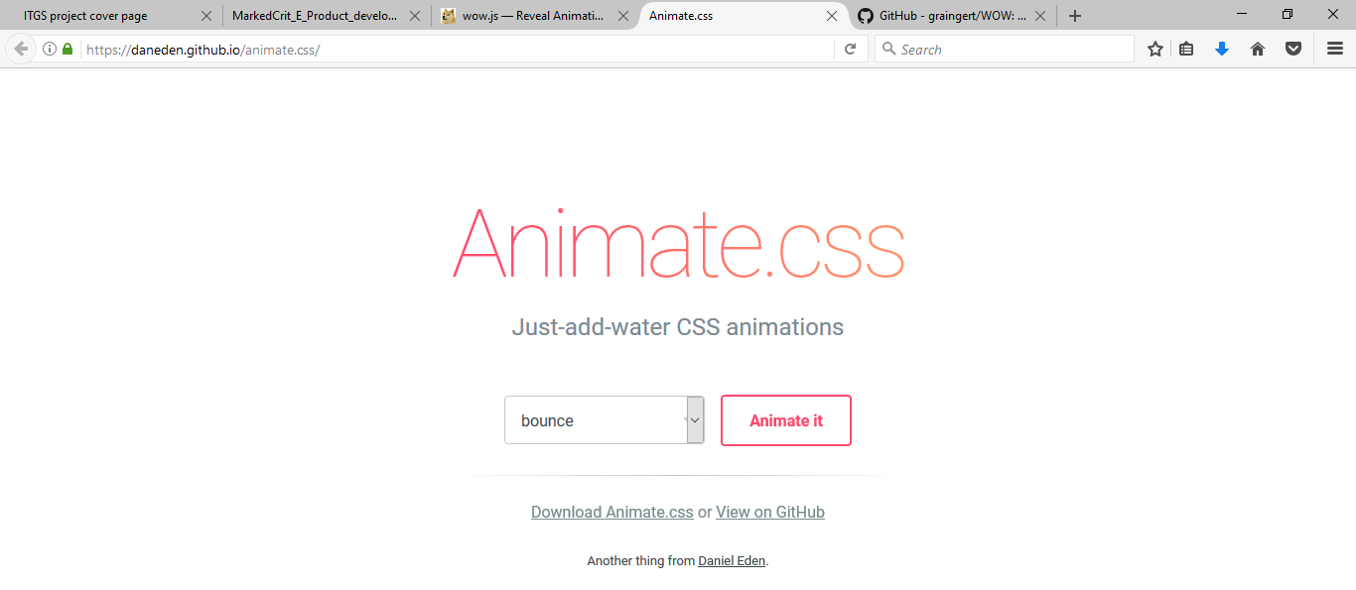

Wow js was downloaded from github:-

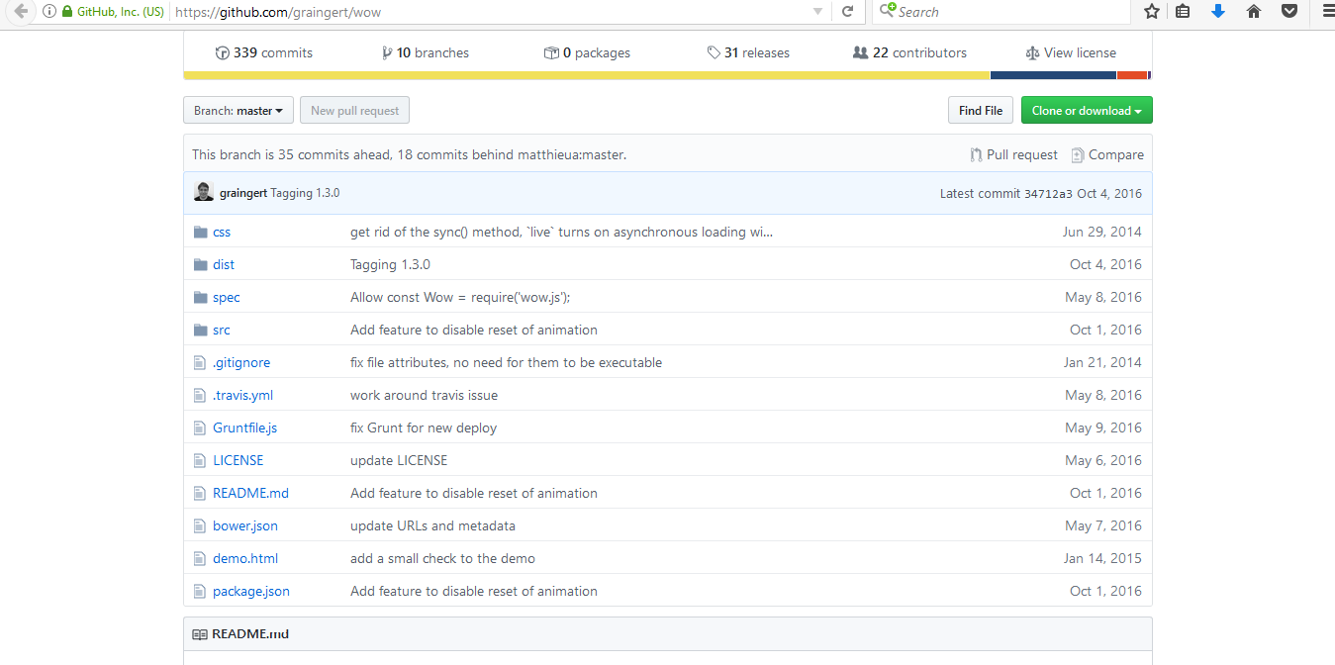

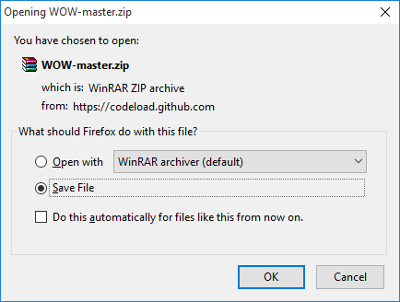

The necessary CSS and JavaScript were linked to the webpage using the code below:-

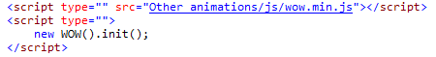

I have used these 2 websites for this simple animation because the code for executing the animations were very simple and smaller than other animation codes available.The animation was applied in the class attribute of a particular object by calling specific animation names.

The animation class names and the demonstration of it was available in **animate.css** ("Animate.Css". *Daneden.Github.Io*, 2018, https://daneden.github.io/animate.css/).

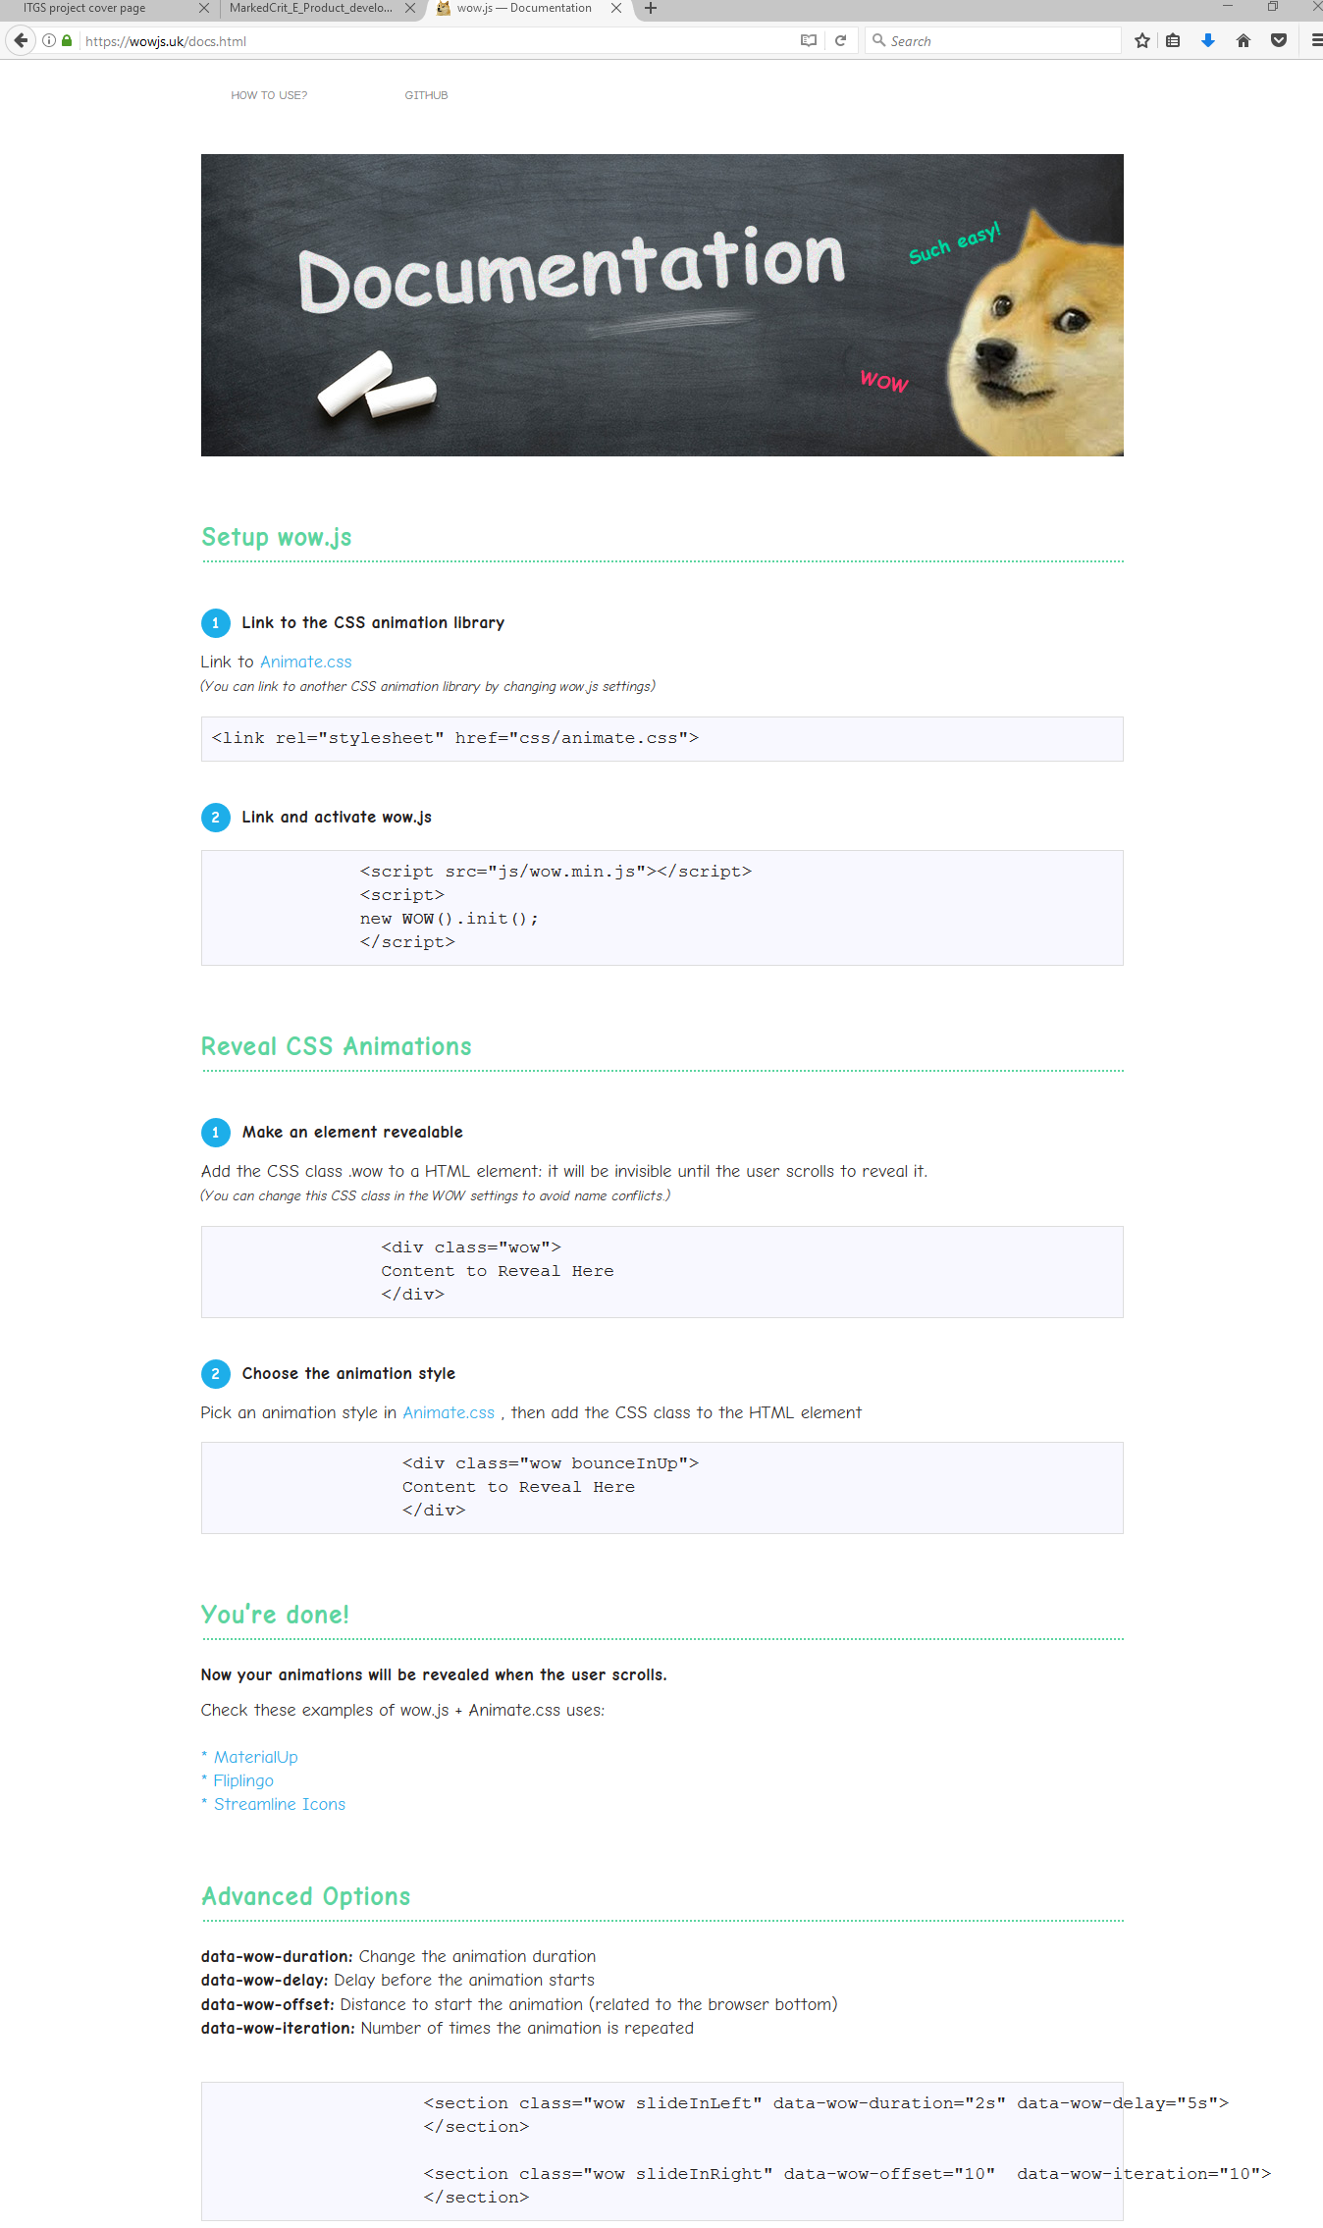

Screenshot of the documentation of **wow js**

**(**"Wow.Js — Documentation". *Wowjs.Uk*, 2016, https://wowjs.uk/docs.html.**)**

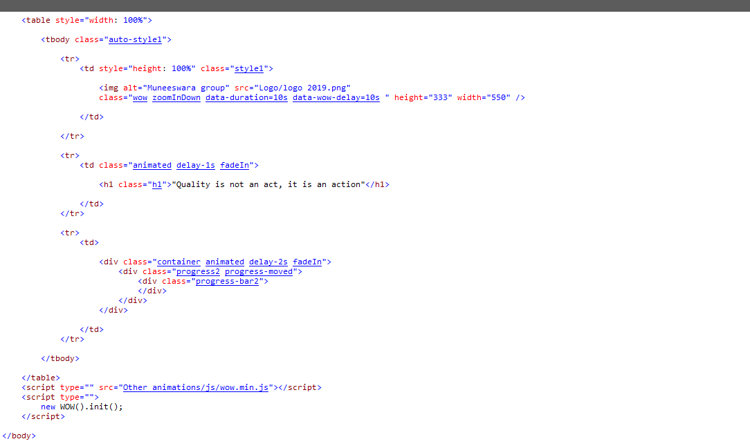Html code for the progress bar including the animation code:-

(Wythien, Eva. "Eva Wythien". *Codepen*, https://codepen.io/evawythien/pen/jegRxN.)

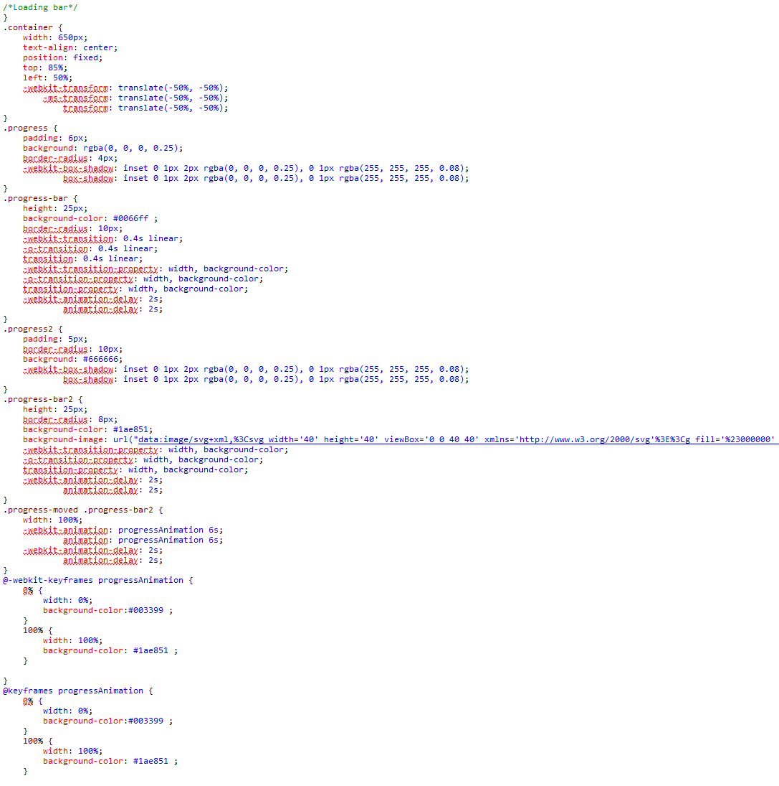CSS code for the progress bar:-

.............

Html code for the 3 objects in this page:-

Animation classes applied

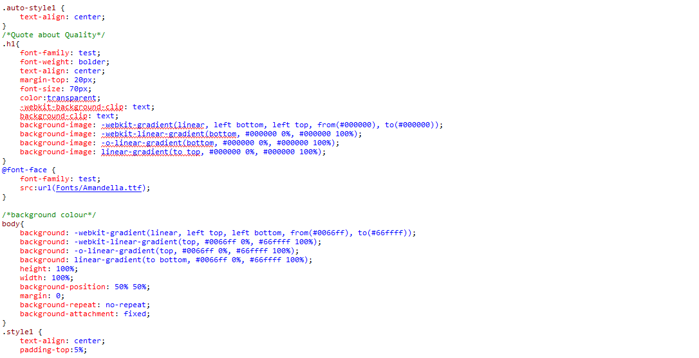

CSS code for styling the quote

CSS code for importing downloaded fonts

CSS code for the background colour gradient

**Additional information**

* Autoprefixer (<https://autoprefixer.github.io/>) was used to do vendor fixes in the CSS code, so that the website was viewable in all the web browsers.
* Html (<https://htmlformatter.com/>)and CSS cleaners (<https://html-cleaner.com/css/>) were used to tidy up the coding (proper indentation and spacing of coding) because a neat code can be understood by developers rather than a shabby code during future developments.